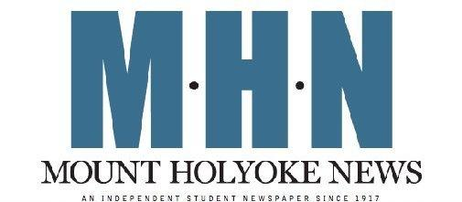

Mount Holyoke News Layout Assistant Application

Thank you for your interest in joining Mount Holyoke News. MHN is a weekly, student-run publication aimed at providing the most current and relevant news to the Mount Holyoke College community.

Position Description:

Layout Assistants help to design the paper. This includes designing spreads, arranging photos/graphics and placing articles. Layout Assistants must have an eye for detail and design experience. Familiarity with Photoshop and InDesign (or other publishing software) is preferred but not required. Layout Assistants report to the Managing Editor of Layout.

We are looking to fill our openings with dedicated and reliable students. To apply, complete this application and email it to mhnews@mtholyoke.edu or drop off a physical copy to Blanchard 324. Feel free to use additional pages. If you have any questions, please contact us at the email address above.

Name: ______________________________________ Class Year: ____________________

Email (MHC preferred): __________________________ Phone: ______________________

Preferred Pronouns: _________________ Major/Minor: _____________________________

1. Why are you interested in joining Mount Holyoke News? What skills will you bring to the layout department and what do you hope to gain from working for MHN?

2. What prior experience do you have with layout/design?

3. Are you proficient in any creative software (i.e. Photoshop, InDesign, Illustrator, etc.)? If so, please elaborate on your familiarity with each program.

4. What other time commitments will you hold in the 2018-2019 academic year (sports, academic overload, study abroad, etc.)? Joining Mount Holyoke News is a considerable time commitment, but MHN staff helps individuals interested in joining the newspaper create workable schedules.

