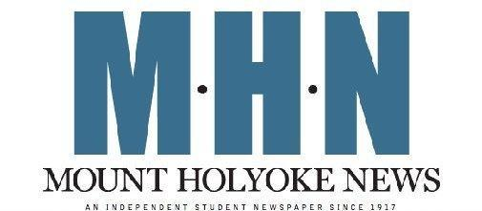

Mount Holyoke News Web Editor Application

Thank you for your interest in joining Mount Holyoke News. MHN is a weekly, student-run publication aimed at providing the most current and relevant news for the Mount Holyoke College community.

Position Description:

Web Editors are responsible for uploading the weekly content of Mount Holyoke News onto our website and are a vital part of MHN’s team. Web Editors should be comfortable with technology and detail-oriented. While specific hours are flexible, Web Editors will be busiest on Thursdays and Fridays, when we accomplish the bulk of publishing both in print and online.

We are looking to fill our openings with dedicated and reliable students. To apply, email your completed application to mhnews@mtholyoke.edu or drop off a physical copy to Blanchard 324. If you have any questions, please contact us at the email address above.

Name: ____________________________________ Class Year: _____________________

Email (MHC preferred): ___________________________ Phone: ______________________

Preferred Pronouns: _________________ Major/Minor: ______________________________

1. Currently, there are several responsibilities that fall under the umbrella of “Web Editor,” including content management, social media management and website design. What job(s) most interest you?

2. Please elaborate on any pertinent experience you have, including any familiarity with InDesign, Squarespace, Wordpress and/or any other publishing software. List any experience with Mount Holyoke News first, but feel free to include experience in high school and outside of college. While experience will be considered during the selection process, it is not required.

3. Joining Mount Holyoke News is a substantial time commitment; Web Editor positions will demand 2-5 hours per week. What are your other large time commitments for next year that might interfere with your commitment to MHN? (SGA, sports team, thesis, more than 16 credits)

4. Finally, why are you interested in joining Mount Holyoke News? What skills could you bring to the paper, and what do you hope to gain from joining MHN’s team?

